CREATE JAVA APPLICATION

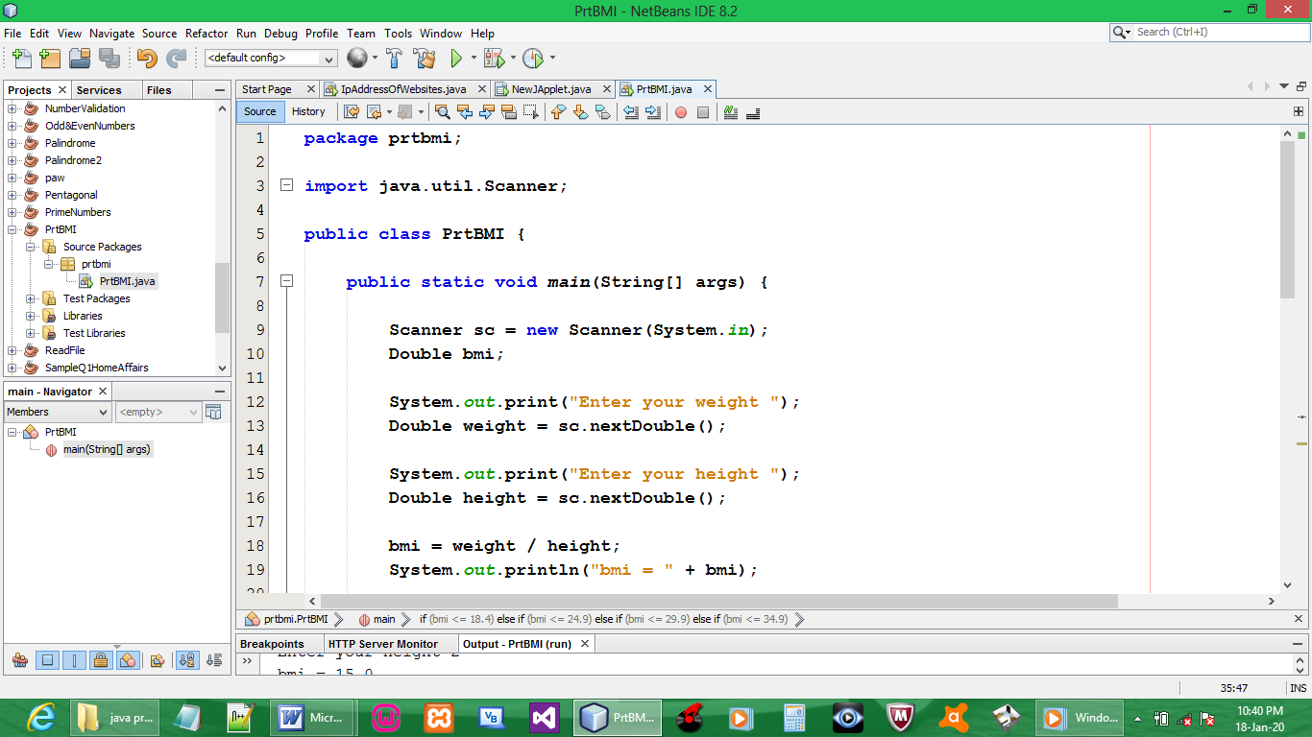

CODE:

package prtbmi;

import java.util.Scanner;

public class PrtBMI {

public static void main(String[] args) {

Scanner sc = new Scanner(System.in);
Double bmi;

System.out.print("Enter your weight ");
Double weight = sc.nextDouble();

System.out.print("Enter your height ");
Double height = sc.nextDouble();

bmi = weight / height;
System.out.println("bmi = " + bmi);

if (bmi <= 18.4){
System.out.println("Underweight");
System.out.println("See your nutritionist");
}
else if (bmi <= 24.9 ){
System.out.println("Normal weight");
System.out.println("Maintain your diet");
}
else if (bmi <= 29.9){
System.out.println("Overweight");
System.out.println("Consider exercising and see a nutritionist");
}
else if (bmi <= 34.9){
System.out.println("Obesity(Class 1)");
System.out.println("Exercise and adjust your diet");
}
else if (bmi <= 39.9){
System.out.println("Obesity(Class 2)");
System.out.println("Be on a diet plan immediately and exerise daily");
}
else if (bmi >= 40.0){
System.out.println("Extreme Obesity(Class 3)");
System.out.println("Get medical attention");
}
}
}

OUTPUT:

